Ex.no:6c | DATA VISUALIZATION USING POWER BI  (WORLD HAPPINESS PREDICTION)

Aim:
To clean, preprocess, and transform the raw World Happiness Prediction dataset, load the cleaned data into Power BI, and build an interactive visual dashboard to analyze happiness preparation, sales, Ranking, and year-wise patterns.
Algorithm:
- Import Dataset: Load World_Happiness_Dataset.csv into the environment.
- Deduplication: Identify and delete duplicate rows across all fields.
- Remove Blank Rows: Identify and remove completely blank records from the dataset.
- Handle Missing Values: Identify missing values in each column and replace or remove them appropriately to maintain data consistency.
- Handle Data Type Errors: Convert numerical attributes such as Prepared_Quantity, Sold_Quantity, Remaining_Quantity, and Waste_Amount into appropriate numerical data types.
- Clean Text Data: Remove unnecessary spaces and standardize categorical values such as Year, City, and Ranking.
- Create Waste Calculation: Calculate the remaining Avg happiness and Max/Min happiness where required using the prepared and sold quantities.
- Load Clean Data: Load the cleaned world happiness dataset into Power BI Desktop using Get Data → Text/CSV and select Transform Data if further cleaning is required.
- Create Core Metric: Create a measure in Power BI to calculate the total Happiness percentage.
- Create Dashboard: Build interactive visualizations such as KPI cards, bar charts, pie/donut charts, and slicers to analyze restaurant-wise, city-wise, and food-item-wise waste patterns.

Output:
1.BAR CHART
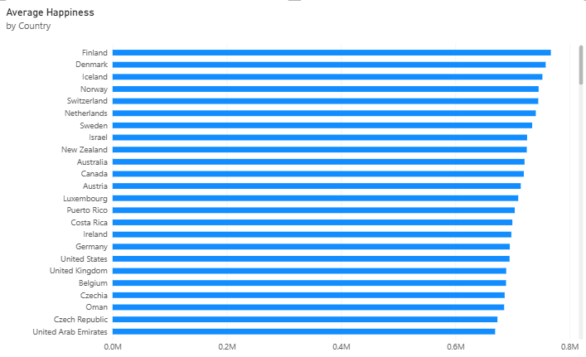
2.Column Chart
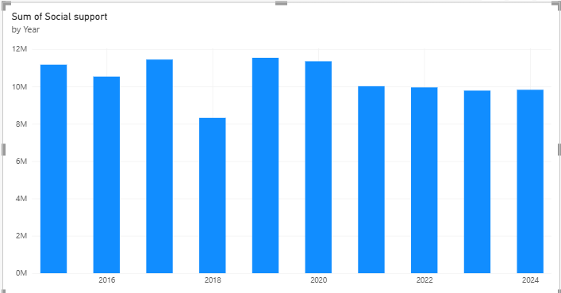

3.Donut Chart
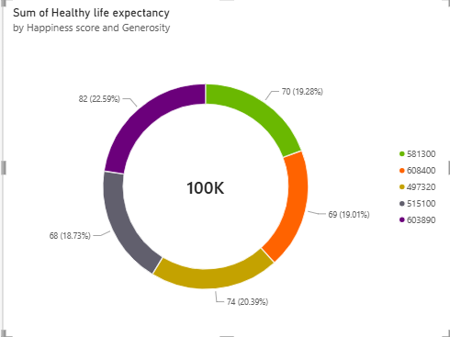
4.KPI CARD
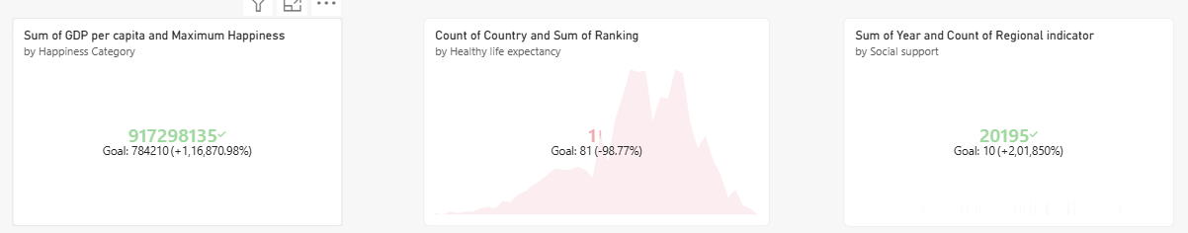
5.Line Chart
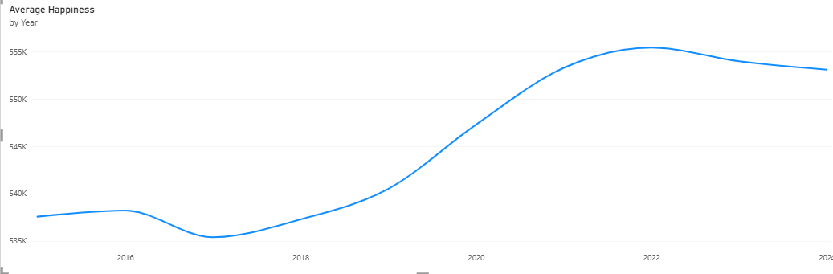

6.Clustered Column Chart
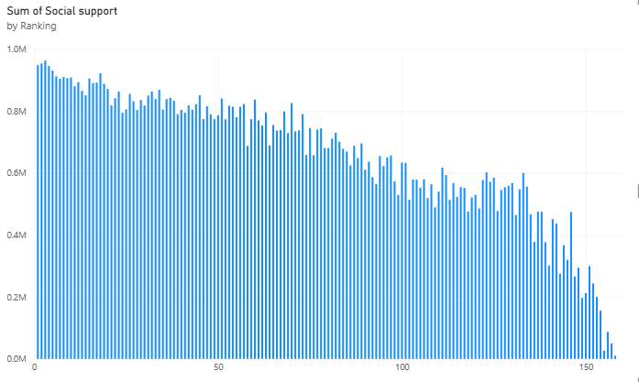

7.DASHBOARD

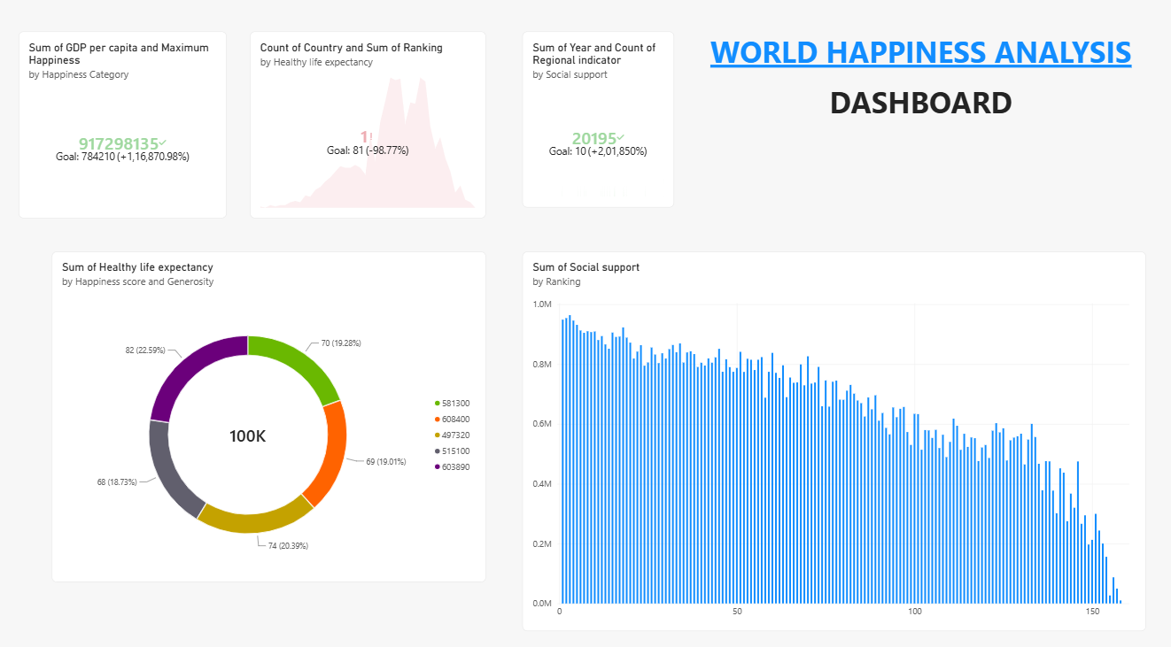

Result:

